Wild backyards: Digital stories transcripts
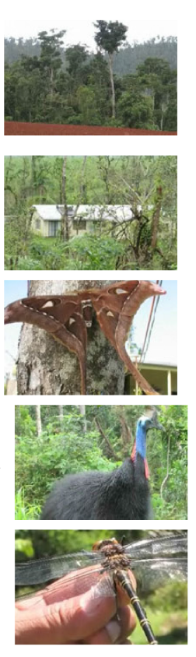

Wild backyards: Innisfail story transcript
Creator: Hasenpusch, J.
We live just north of Innisfail in North Queensland. We’re tucked behind sugar cane and banana farms in the coastal Seymour Range. Our backyard is dense tropical mesophyll vine forest of about 80 acres. We live in two small cleared areas for our houses and the rest of the yard comprises several pristine rainforest streams, which are just full of fish and all sorts of creatures. We use our backyard for research and the tracks left over from logging days give great access to the forest. We see some amazing animals, it’s never dull and something different always comes along.
A regular sight here at night is the Giant Hercules Moth. This is the largest moth in the world. Their caterpillars grow as large as pork sausages as they hang from their food plants.
Most of the wildlife in our backyard lives, feeds and breeds right here. Others, like Paradise Kingfishers and swamp wallabies only spend a short time here before moving on. We like to see lots of insects in our backyard flying, mating, pollinating the flowering trees we’ve supplied, and we never get tired of seeing all the birds and hearing their calls, especially the scrub hen and Wompoo Pigeons, but our favourite of them all is the giant Southern Cassowary. We have colourful jewel beetles which feed on the flowering trees we’ve put in and mountain blue and birdwing butterflies fly around and glide around them all the time.
One day, while I was talking to some visitors down came the largest dragonfly species in the world. It’s called Petalura ingentissima and it landed on my head, of all places. This dragonfly’s huge and has a wingspan of 6 inches. I commented to our visitors: ‘Must be my animal magnetism’. And we all laughed as it flew away.
We get animals to breed in our backyard by supplying a safe environment here for them to live in. We have a pet kelpie dog and her name’s Brandy and we’ve even trained her not to chase animals. Leaving logs and fallen branches provides a great place for many creatures to shelter, and growing flowering trees and food plants such as the birdwing food plant vine allows butterflies to breed and be a feature of our backyard all year round.
Source: Wild backyards: digital stories transcript, (c) The State of Queensland (Queensland Museum) 2010-2012 http://www.qm.qld.gov.au/microsites/wild/pdf/200804_wildbackyards_transcript.pdf CC BY-NC-ND 3.0 creativecommons.org/licenses/by-nc-nd/3.0/au/deed.en
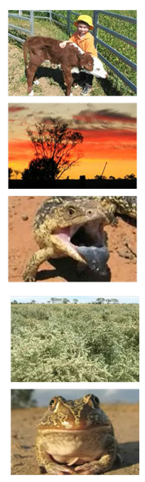

Wild backyards: Roma story transcript
Creator: Eddie, C.
Our backyard is a 40 acre rural block on the outskirts of Roma in southern inland Queensland. When we moved into our house six years ago, there was virtually no garden. Gardening is a real battle here and with our scorching summers and ongoing drought it is a real achievement to get anything to survive.
We’ve planted native trees and shrubs, mainly those that occur naturally in the area as they tend to do best in our harsh conditions. We’ve planted matt rushes, flax lilies, spinifex and sedges to provide ground cover for small creatures like skinks, and shrubs such as Eremophila, callistemons, saltbushes and grevilleas to provide cover for small birds. Our trees are mainly Eucalypts, but we have also planted species with berries for fruit-eating birds. We use all of the leaves and branches that fall from our trees as mulch, and we’ve added logs and rocks as basking and shelter sites for reptiles.
Our garden’s pretty quiet in the winter months, but in the warmer months, we’re visited by Eastern Blue-tongued Skinks, shingleback skinks and Yellow-spotted monitors, and we regularly walk out to find part of the garden dug up by echidnas.
In mid-2005, we planted a small paddock with 3000 old man saltbushes as a trial stock feed. This drought and frost resistant native bushy shrub, which is rich in protein, doubles as good wildlife habitat. It’s been a delight to have White-winged Fairy Wrens move into the saltbush within two years and they have already raised their first brood here.
As our gardens and trees establish, we are slowly recording more and more species of birds. We are especially lucky to live in an area with so many beautiful parrots. It’s not unusual to walk out on any given morning and see Red-winged Parrots, Mallee Ringnecks, Blue Bonnets, Pale-headed Rosellas and Red-rumped Parrots at close quarters.
Several species of frogs breed on our property, in a temporary pond in the saltbush paddock. The pond is also home to fairy shrimps, water bugs, freshwater crabs and water birds such as Black-fronted Plovers, spoonbills, stilts, ducks and ibises. The best thing about our backyard is that we share it with an array of fantastic native animals and by improving the habitat and expanding the gardens we hope to attract even more.
Source: Wild backyards: Digital stories transcript, © The State of Queensland (Queensland Museum) 2010-2012 http://www.qm.qld.gov.au/microsites/wild/pdf/200804_wildbackyards_transcript.pdf CC BY-NC-ND 3.0 creativecommons.org/licenses/by-nc-nd/3.0/au/deed.en
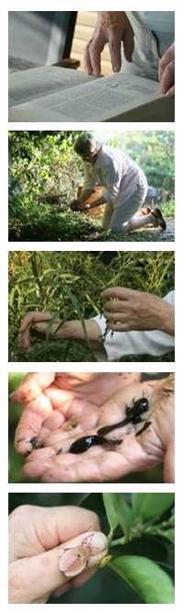
Wild backyards: Brisbane story transcript
Creator: Curtis, S.
I’m Sybil Curtis and my original training was in entomology, and that’s the study of insects, and geology. About four years ago, I moved into a house near Toohey Forest and the suburb is Nathan and I moved here of course to be next to the forest. The little house I purchased was very nice however the garden was virtually non-existent. I started up a garden pretty well straight away. All the plants that I’ve planted are Australian natives.
Perhaps my favourite group of native plants are the wattles because they are just so good for encouraging wildlife. First of all, they grow very fast and that means you can get up a barrier between you and the neighbours within a couple of years. Secondly, the flowers attract a whole lot of bees and wasps and those sorts of things but the very best part is when they seed, seed-feeding birds come and these are the spectacular ones, King Parrots and rosellas, and I can sit on my little back verandah and watch them feeding. The other thing that wattles do is they add nitrogen back into the soil, and they’re really, really tough plants. The last few years in Brisbane it hasn’t rained at all but I think every wattle I’ve put in the ground has flourished.
One of the really important things to encourage wildlife is to put in some water, and to do this all I’ve done is dug some holes and put in some large plastic tubs. It does a couple of things. First of all the wildlife can come and have a drink any time they feel like. It humidifies the plants that are around it. And your frogs will just turn up all by themselves; you don’t have to move any tadpoles in. You put in some water, and they will come.
The other important thing to do is to just leave a whole heap of rubbish around as I say. Now rubbish doesn’t mean plastic bags or things but it does mean sticks and logs, and this gives great little places for animals like lizards to hide. The other thing it does is keep the scrub turkeys from being able to scratch properly.
If I could say one thing about how to encourage animals in your yard, first of all, put in a diversity, a whole lot of different plants. And, be delighted when you find your plants have been chewed to pieces, because if they’re chewed to pieces it means there are insects in your garden. And what insects do is they convert that pretty tough plant material into bite size pieces of fat and protein for all the birds and lizards and anything else to eat.
Source: Wild backyards: Digital stories transcript, (c) The State of Queensland (Queensland Museum) 2010-2012 http://www.qm.qld.gov.au/microsites/wild/pdf/200804_wildbackyards_transcript.pdf CC BY-NC-ND 3.0 creativecommons.org/licenses/by-nc-nd/3.0/au/deed.en

